
NATIONAL UNIVERSITIES OF MODERN
LANGUAGES
FACULTY OF ENGINEERING AND COMPUTING
DEPARTMENT OF SOFTWARE ENGINEERING

Course Name: WEB-II
Assignment No./ LAB – Task /Project LAB 3: Node JS Installation
Date: 2 Oct, 2025
Submitted by
Class: BSSE (VII) Section - Sessions (M/A) Afternoon
Name: Zulqarnain Hassan Roll No. Sp-21379
Submitted to
Instructor Name: Mr. Danish
To be filled by Instructor
Instructor Comments:
Marks Obtained: Total Marks:
CLO No. :

LAB 3: Node JS Installation

- Install Node.js on your machine by following above manual

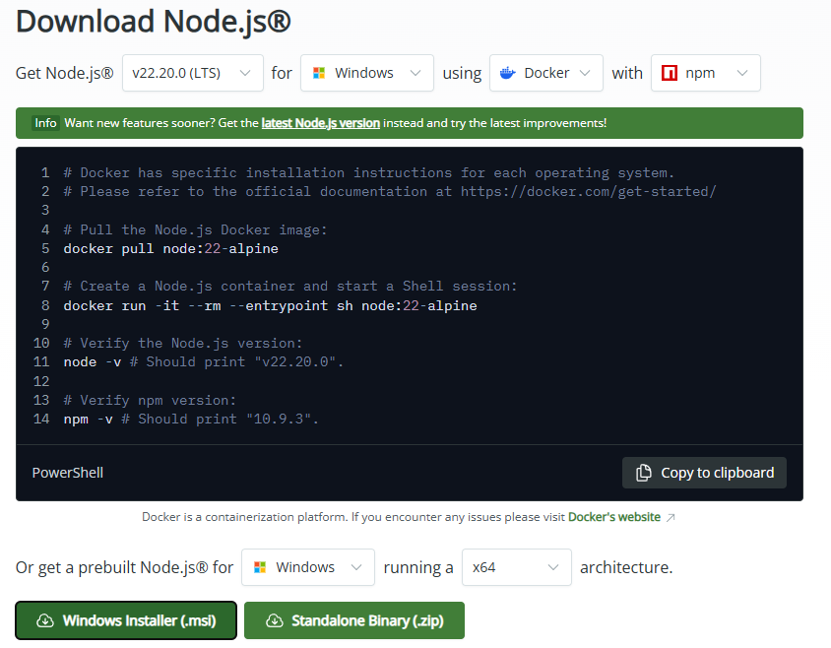

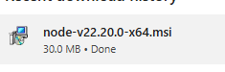
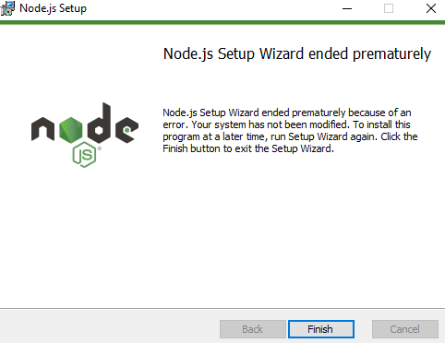

- Verify installation and prepare lab manual

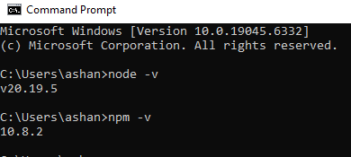
- Create an app to send Email from Node.js. Follow the tutorial on: https://www.w3schools.com/nodejs/nodejs_email.asp For reference: https://blog.logrocket.com/send-emails-nodejs-nodemailer/

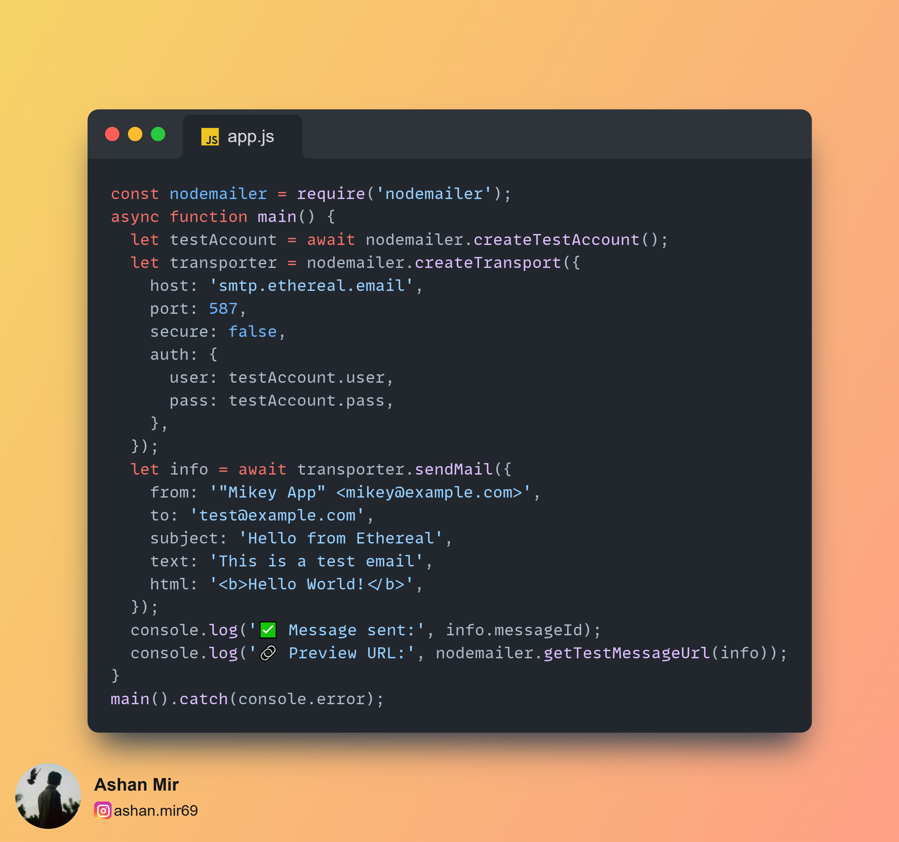

Output:

